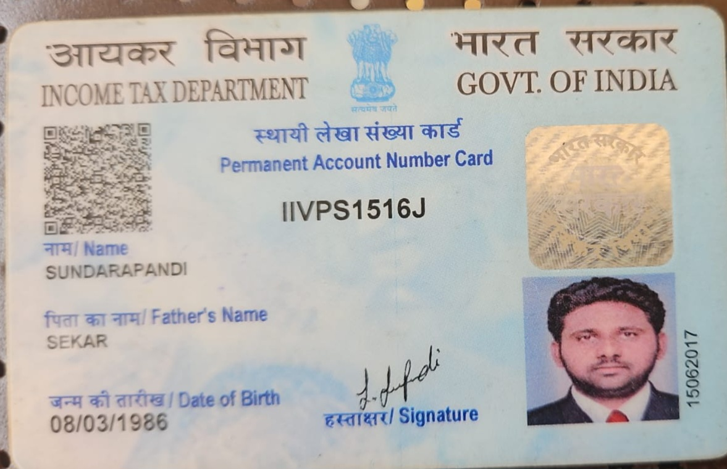

Candidate's Full Legal Name (as it appears on PAN) | Sundarapandi
Supplier Name (Registered Name) | People-prime Worlwide
Worked for CG previously? (IF yes share CG  Employee ID/GGID required | No
JOB Posting ID | CGEMJP00344240
Contact No (10 Digit No) | 8144463441
Email ID | sekarsundarapandi86@gmail.com
Job Location (Work Location) | Pan India (Chennai)
Notice Period (Immediate/ Notice to Serve) | Immediate Joiner
Highest Education (Regular or Distance) | BE 2009
Employment Detail – Last 2 yrs Working period  (Payroll Company) | TCS
College & University Full Name -Biju Pat t naik University T echnology | Seethaiyammal College of Engineering and Technology
Mandatory Skills & Experience  (quick checklist – verify each skill, years of  experience) | .Net core 12 , Microservices-4 Years
“Secondary” Skills & Experience | Azure Devops- 5.5 Years
Key Remarks (Supplier Comment) | Candidate Good at Communication Skill. He has relevant experience of 12 Years

S.Sundarapandi
No:30 3 street,
BE-(Computer Science Engineering) Rajeshwari Nagar, Thaiyur
E-Mail: sekarsundarapandi86@gmail.com Chennai-601103,
Mobile: +91-8144463441 Madurai-625207.

Professional Objective:
Looking forward for challenging and significant career. To work in a professional environment where I can enrich my skills and work towards the organization goals.
Technical Skills:
- Languages : C#,ASP.NET,WCF,Micro Service,MVC, Reactjs ,.Net framework 7
- Database : Sql Server 2019
- Reporting : Crystal Report 2008
- Operating System : Windows
Professional Summary:
- 3+ Years of experience in WCF and Micro Service and Reactjs as a developer using .Net C#.
- Around 9 years of experience in Development and implementation of various Internet web applications and Database using Asp.net, C#, SQL Server,WCF,MVC.
- Good Extensive experience in Developing/Handling highly interactive web-based applications.

Professional Experience:

Organization: Tata Consultancy Services Limited
Duration: Aug 2022 to Aug 2025
Technology: Micro Service, Sql Server 2019

Organization: Future Focus Infotech Pvt Ltd
Client : Tata Consultancy Services Limited (Contract)
Duration: Jul 2021 to Jul 2022
Technology: Micro Service, Sql Server 2019

Organization: Alchemy Techsol India Pvt.Ltd
Client : Cognizant Technology Solutions (Contract)
Duration: Mar 2018 to Jan 2020
Technology: WCF, MVC, Sql Server 2017

Organization: Orbitz it solution
Duration: Oct 2016- Feb 2018
Technology: Net, Sql Server 2008

Organization: Vairang Technologies Pvt. Ltd
Duration: Mar 2011- Sept 2016
Technology: .Net, Sql Server 2008

Project Experience :

Organization: Tata Consultancy Services Limited

Project: ALDI Stores

Role : Developer
Team Size : 10
Technologies Used: .Net C#, Micro Service and WCF, SQL server 2017
Duration: Sep 2022 – Aug 2025
Client:
Aldi's German operations consist of Aldi Nord's 35 individual regional companies with about 2,200 stores in western, northern, and eastern Germany, and Aldi Süd's 32 regional companies with 2,000 stores in western and southern Germany.

Service:
- Item Management
- Sales Management
- Stock Management
- Store Inventory Management

Organization: Cognizant Technology Solutions
Project: Johnson & Johnson

Role : Developer
Team Size : 5
Technologies Used: .Net C#, WCF, MVC, SQL server 2017
Duration: Mar 2018 to Jan 2020

Client:
Johnson & Johnson is an American multinational medical devices, pharmaceutical and consumer packaged goods manufacturing company founded in 1886. Its common stock is a component of the Dow Jones Industrial Average and the company is ranked No. 37 on the 2018 Fortune 500 list of the largest United States corporationsby total revenue.

Project: ERP (Enterprise Resource Planning)

Role : Software Developer
Environment : ASP.NET, C#.Net, SQL server 2008, Web Application
Duration: Oct 2016- Feb 2018

Description:
An enterprise resource planning (ERP) project is a large enterprise program, both from a business and technology point of view. This application is mainly developed for sales and Purchase. Maintain Reports foreachModule.

Module
- Accounts receivable
- Accounts payable
- Sales Orders
- Purchase Orders
- General Ledger
- Back Office & Store Management
- Handle multiple customers at a time
- Invoicing and Accounting Integration
Responsibilities: Understanding requirements, Coding and Testing.

Project: Restaurant POS

Role : Software Developer
Environment : C#, Windows Application
Duration: Mar 2011- Sept 2016

Description:
This Application is effective software for handling the Customer Order and handles Number Of customers. This application is used to maintain the customer Orders and Take-Home Option, Calculate Interest For an item for invoicing for each customer and To Maintain Reports.

Responsibilities: Understanding requirements, prepared User Interface, Coding and Testing.

Academic Qualification:

- B.E. (Computer science) in Seethaiyammal College of Engineering and Technology, Madurai affiliated to Anna University Chennai, with 66% 2009.
- Diploma (Computer science) in Thanapandiyan polytechnic College, with75% 2006.
- SSLC in Govt kaller Higher Secondary School, with 62% April 2000.

Personal Details:
Name : S.SUNDARAPANDI
Date of Birth : 08/03/1986
Nationality : Indian
Language Known : Tamil &English
Permanent Address : Vikkiramagalam post, v. naduvoor
Madurai-2

Declaration:
Date : Signature

